AI ASSISTED CODING
ASSIGNMENT-8.2
Name: A.vishnu vardhan Reddy
HT NO.: 2403A51253
Batch No.:11
TASK – 1
Use AI to generate test cases for a function is_prime(n) and then implement the
function.
Requirements:
• Only integers > 1 can be prime.
•
Check edge cases: 0, 1, 2, negative numbers, and large primes.
Expected Output1
• A working prime checker that passes AI-generated tests using edge
coverage
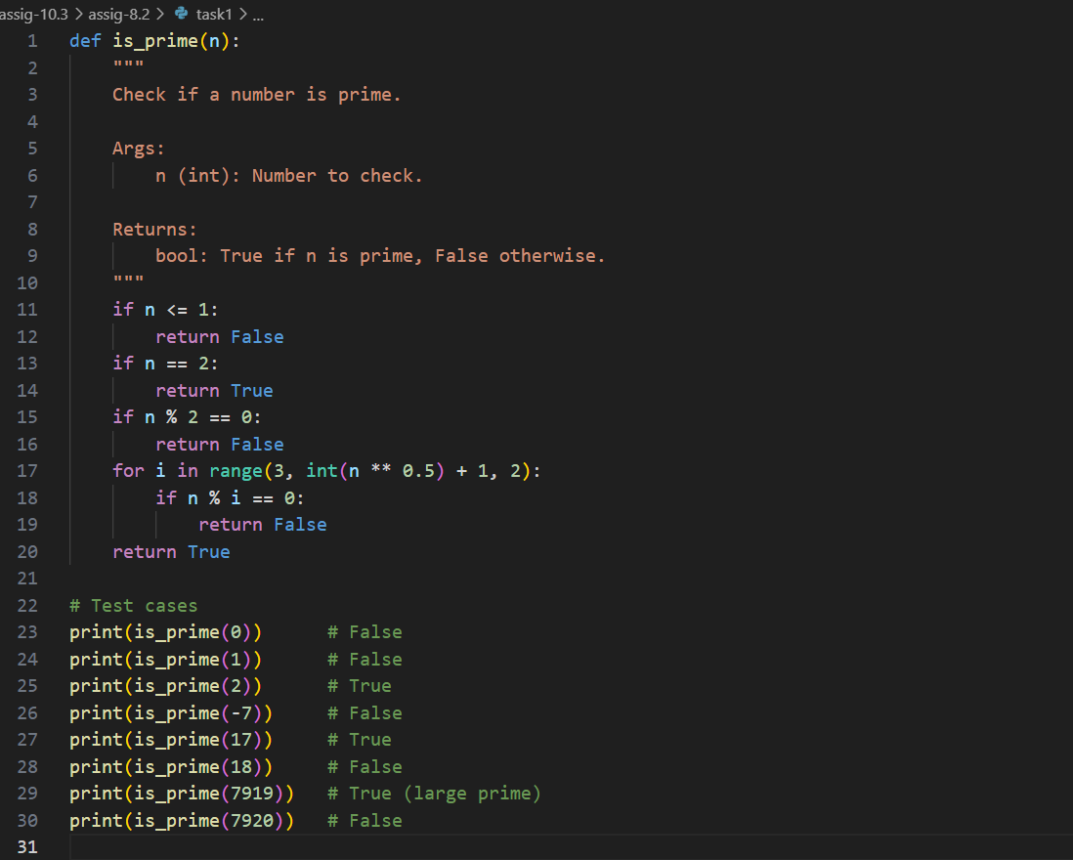
OUTPUT:
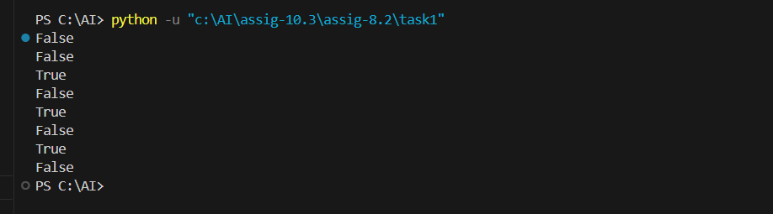
TASK – 2
• Ask AI to generate test cases for celsius_to_fahrenheit(c) and fahrenheit_to_celsius(f).
Requirements
• Validate known pairs: 0°C = 32°F, 100°C = 212°F.
• Include decimals and invalid inputs like strings or None
Expected Output2
Dual conversion functions with complete test coverage and safe type handling
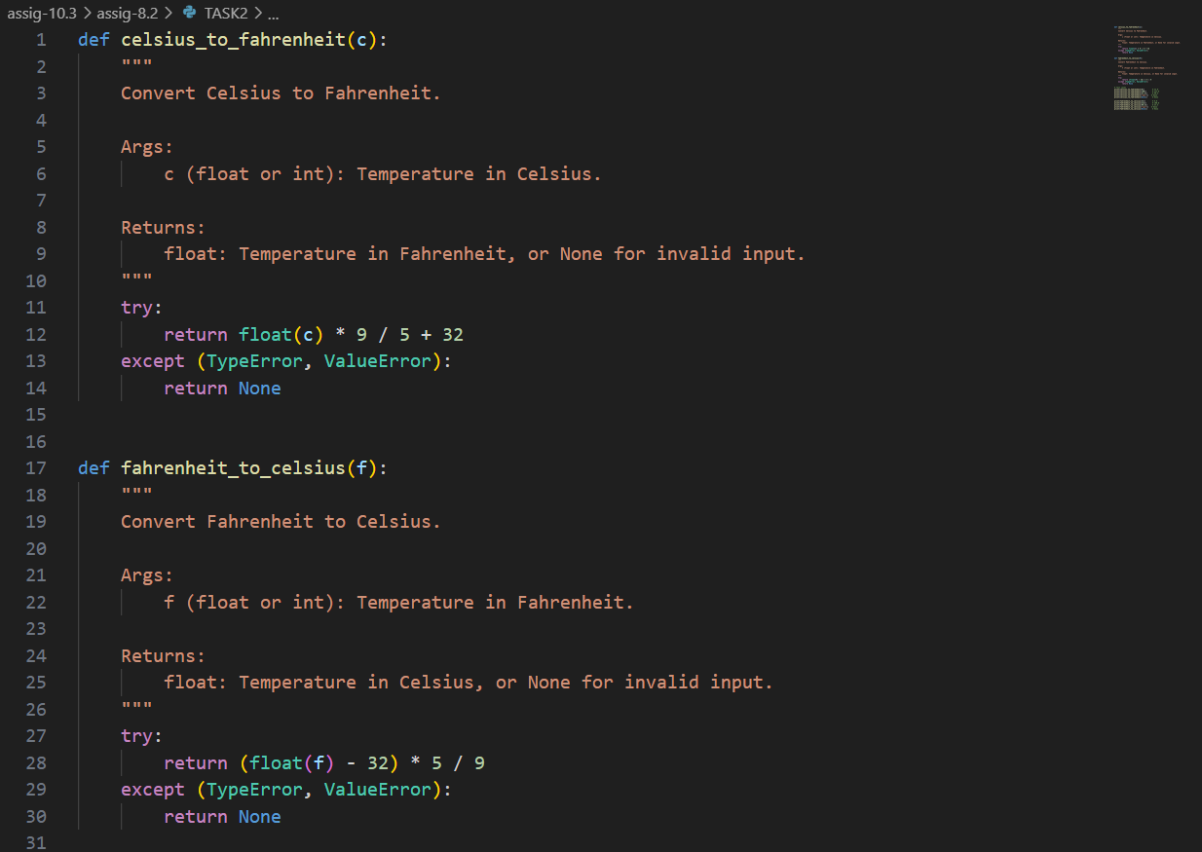
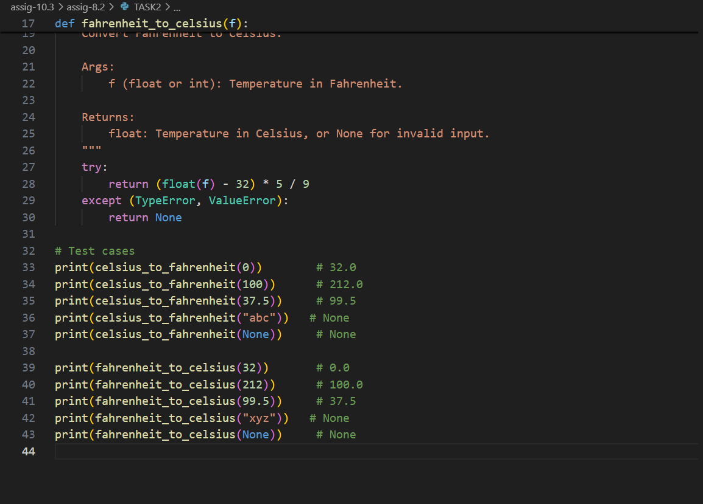

OUTPUT:
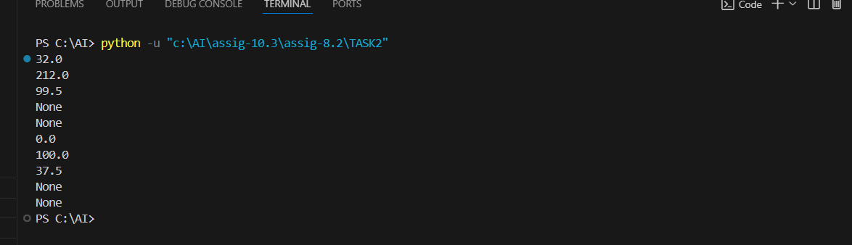

TASK – 3
Use AI to write test cases for a function count_words(text) that returns the number of
words in a sentence.
Requirement
Handle normal text, multiple spaces, punctuation, and empty strings.
Expected Output3
Accurate word count with robust test case validation.
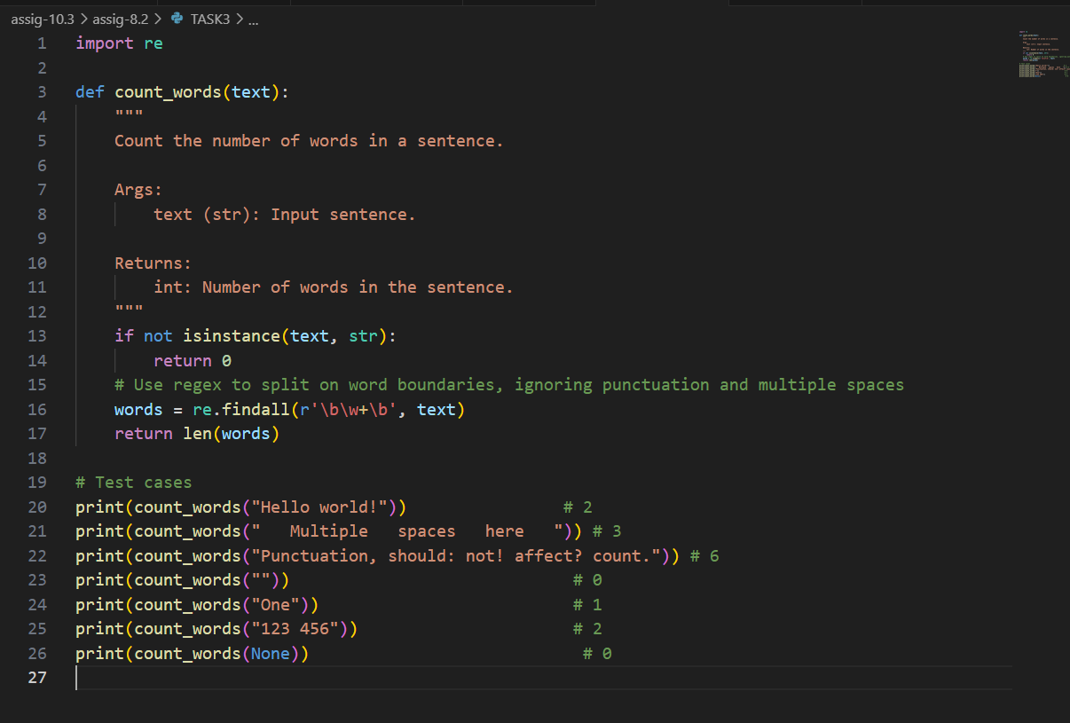
OUTPUT:
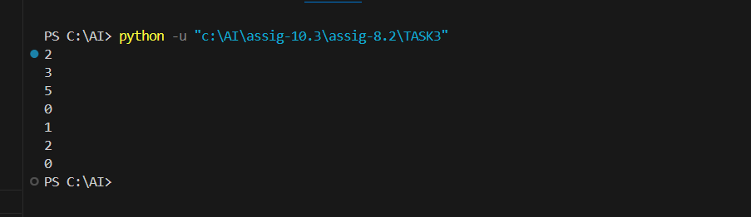
TASK – 4
• Generate test cases for a BankAccount class with:
Methods:
deposit(amount)
withdraw(amount)
check_balance()
Requirements:
• Negative deposits/withdrawals should raise an error.
• Cannot withdraw more than balance.
Expected Output#4
• AI-generated test suite with a robust class that handles all test cases.
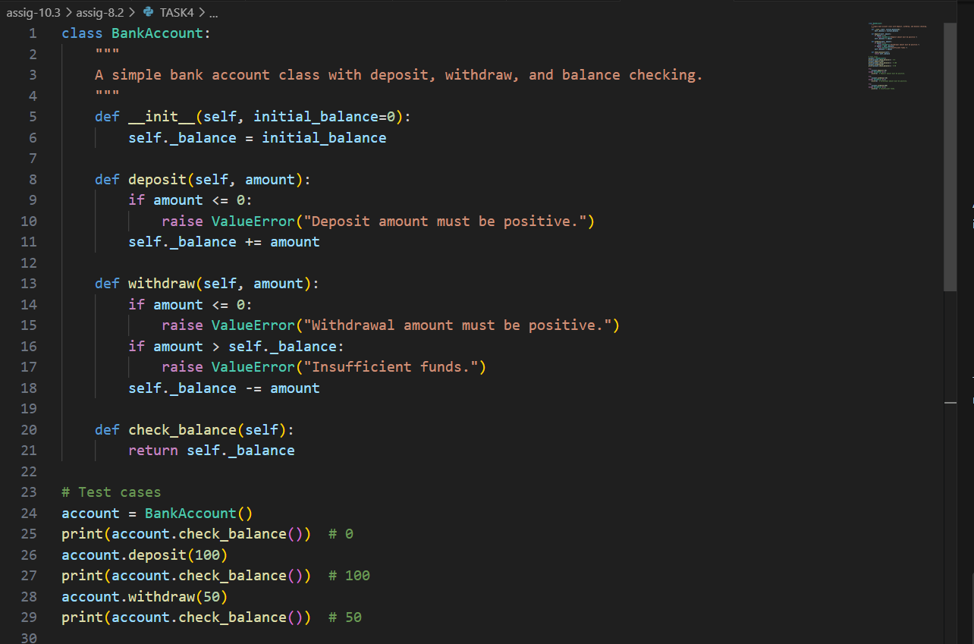
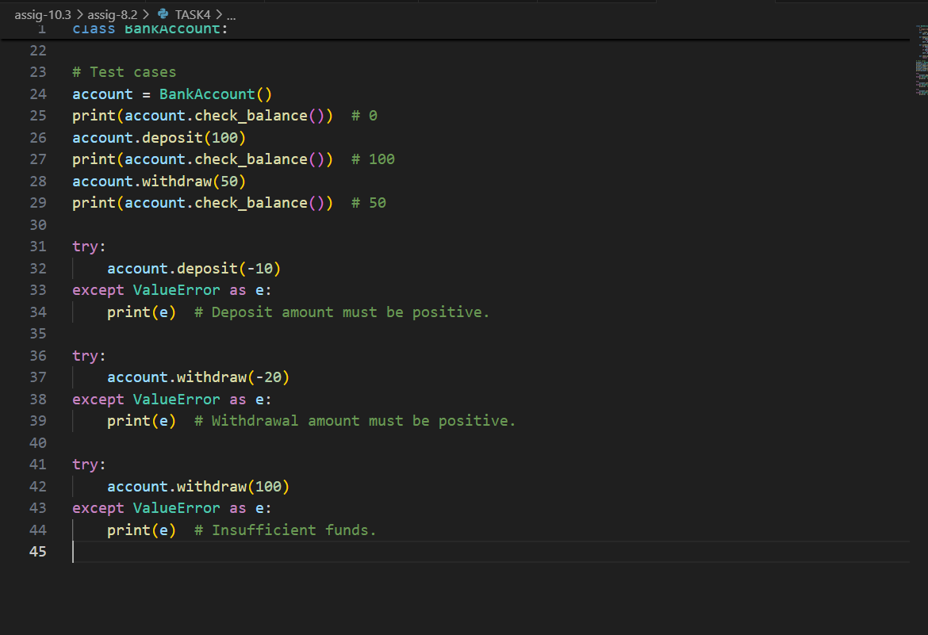

OUTPUT:
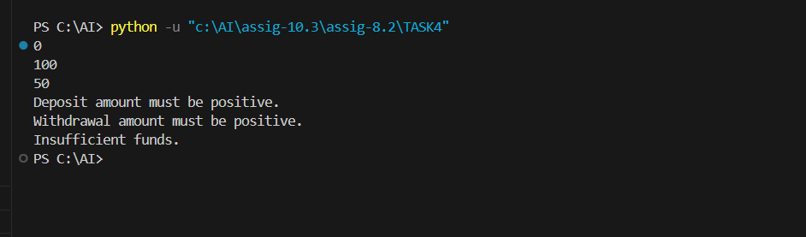
TASK – 5
Generate test cases for is_number_palindrome(num), which checks if an integer reads
the same backward.
Examples:
121 → True
123 → False
0, negative numbers → handled gracefully
Expected Output5
• Number-based palindrome checker function validated against test cases.
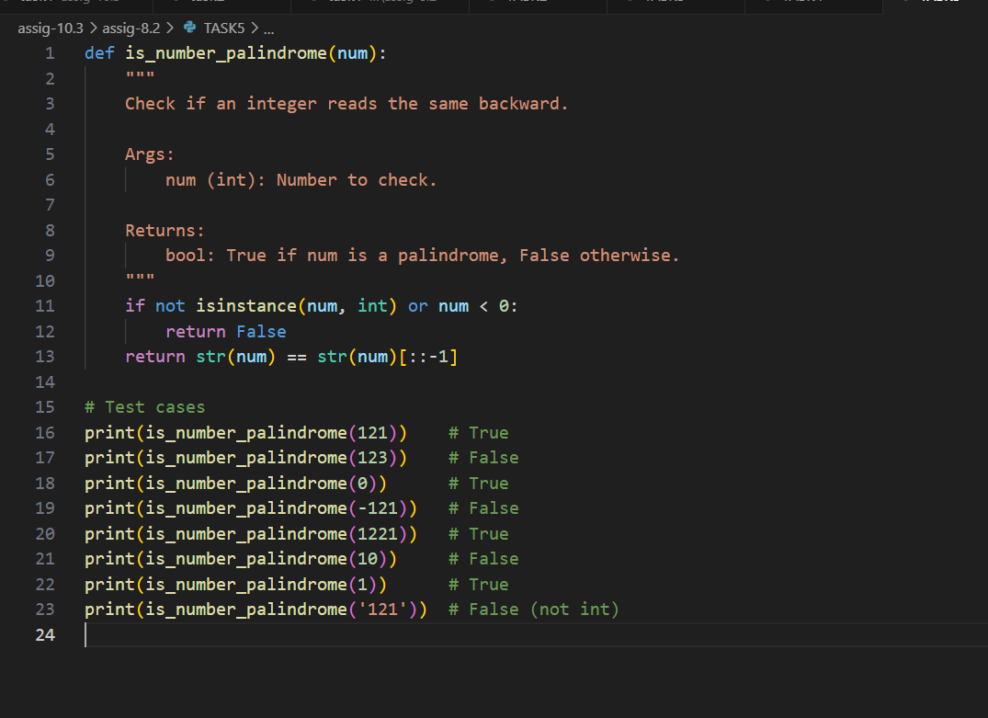
OUTPUT:
